Write a program in assembly language to print multiple characters on screen.

.model small

.stack 100h

.data

input_msg db 'Enter a string: $' ; Message to prompt the user for input

output_msg db 0Dh, 0Ah, 'You entered: $' ; Message to display the output

input_buffer db 50 dup('$') ; Buffer to hold user input (50 characters max)

.code

main:

mov ax, @data ; Initialize the data segment

mov ds, ax

; Display prompt to the user

mov ah, 09h ; DOS function to display string

lea dx, input_msg ; Load address of the input prompt message

int 21h ; Call DOS interrupt to print the message

; Get user input

mov ah, 0Ah ; DOS function for buffered input

lea dx, input_buffer ; Load the address of the input buffer

mov byte ptr [dx], 49 ; Set buffer size (maximum 49 characters)

int 21h ; Call DOS interrupt to get input

; Display output message

mov ah, 09h ; DOS function to display string

lea dx, output_msg ; Load address of the output message

int 21h ; Call DOS interrupt to print the message

; Print the user input string

lea si, input_buffer+2 ; SI points to the first character of user input

; input_buffer+2 skips the buffer size and input length

print_loop:

mov al, [si] ; Load the current character into AL

cmp al, 0Dh ; Check for carriage return (Enter key)

je done ; If carriage return, end the loop

mov ah, 02h ; DOS function to print a single character

mov dl, al ; Move the character into DL (required for int 21h)

int 21h ; Call DOS interrupt to print the character

inc si ; Move to the next character in the string

jmp print_loop ; Repeat the loop for the next character

done:

; Terminate the program

mov ah, 4Ch ; DOS terminate program function

int 21h

end main

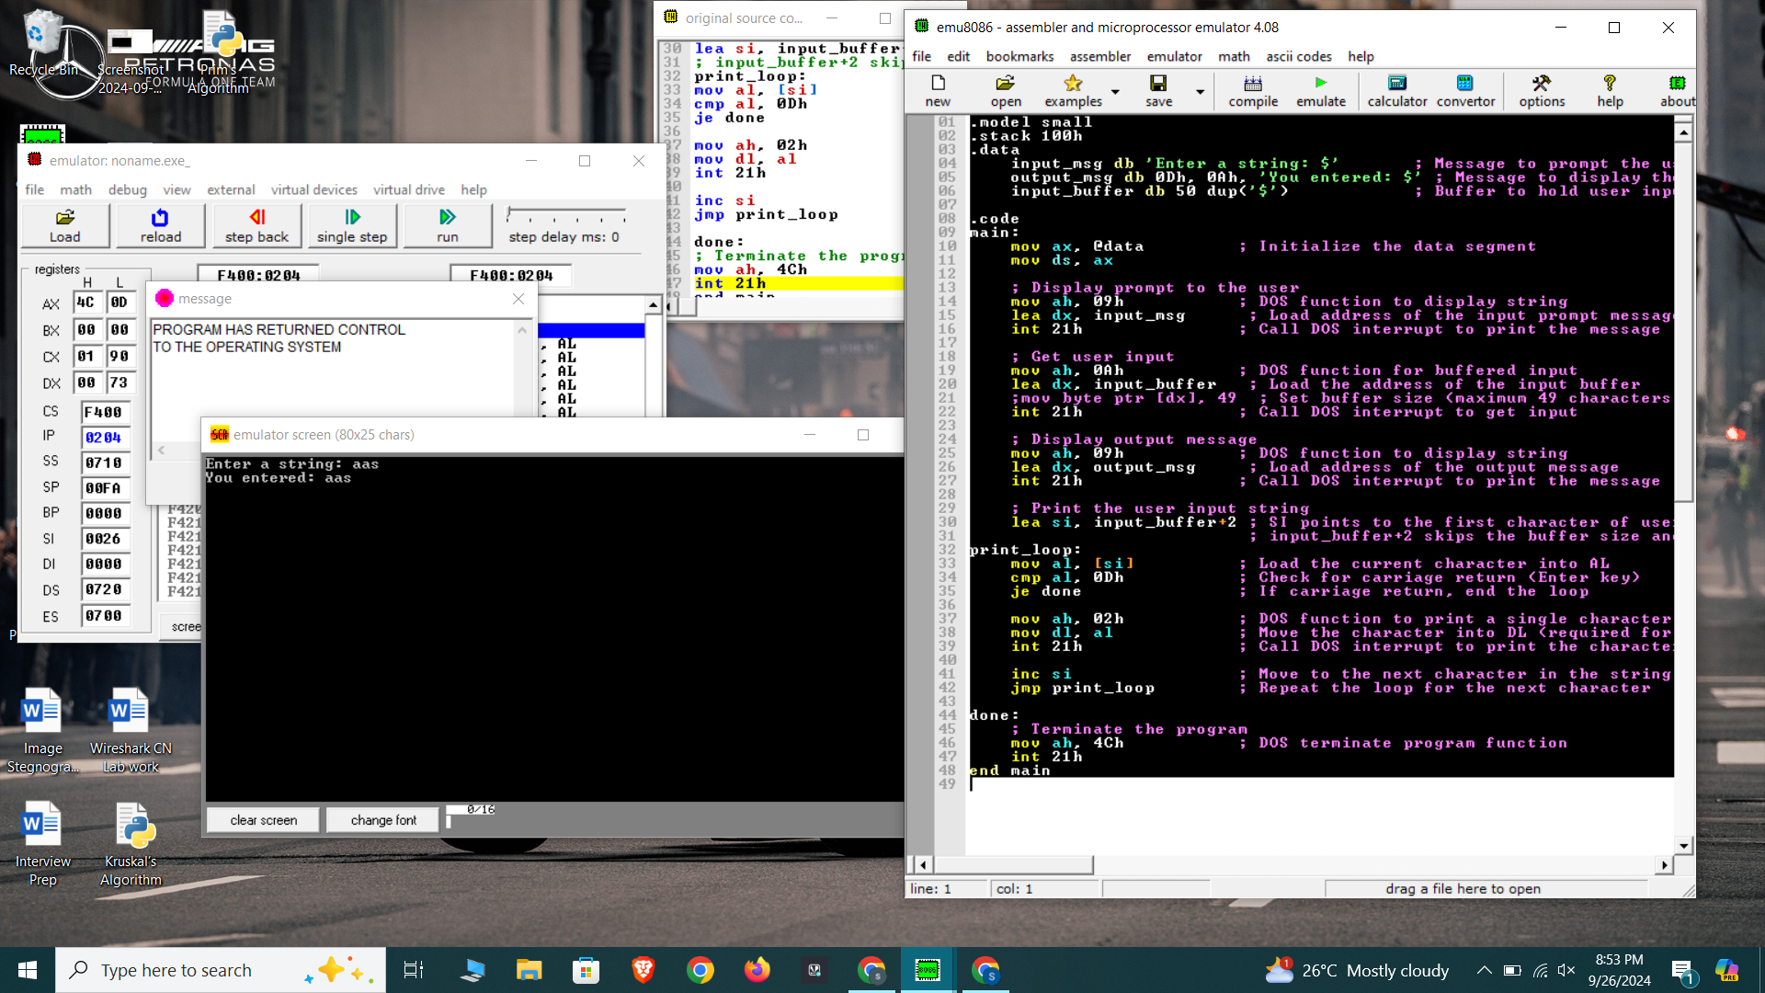

Write an assembly language program to convert a lower-case letter to the

corresponding upper-case letter.

.model small

.stack 100h

.data

msg1 db 'Enter the text: $'

msg2 db 0Dh,0Ah,'Converted text: $'

input db 50 dup('$') ; Reserve space for 50 characters (user input)

.code

main:

mov ax, @data ; Initialize data segment

mov ds, ax

; Display message to ask user for input

mov ah, 09h ; DOS print string function

lea dx, msg1

int 21h

; Get user input

mov ah, 0Ah ; DOS buffered input

lea dx, input ; Load address of input buffer

; mov byte ptr [dx], 49 ; Buffer size (maximum 49 characters)

int 21h

; Convert to uppercase

lea si, input+2 ; Start at the first character (input+2 skips size and actual entered length)

next_char:

mov al, [si] ; Load the current character into AL

cmp al, 0Dh ; Check for carriage return (Enter key)

je done ; If carriage return, we're done

cmp al, 'a' ; Check if the character is lowercase

jl skip ; If less than 'a', skip

cmp al, 'z' ; Check if the character is greater than 'z'

jg skip ; If greater than 'z', skip

sub al, 20h ; Convert to uppercase by subtracting 32 (20h)

skip:

mov [si], al ; Store the converted character back

inc si ; Move to the next character

jmp next_char ; Repeat for the next character

done:

; Print converted text message

mov ah, 09h ; DOS print string function

lea dx, msg2

int 21h

; Print the converted string

lea dx, input+2 ; Load address of the converted string (skip size and length bytes)

mov ah, 09h ; DOS print string function

int 21h

; Terminate program

mov ah, 4Ch ; DOS terminate program function

int 21h

end main

